April–May Mid-century Outlook

## 

Understanding how climate change will impact agriculture in the future can be difficult. It is often helpful to compare future climate projections to the conditions that we are currently experiencing. By mid-century (2040–2069), spring will look a lot different than what we are currently experiencing in terms of increasing temperatures and reduced snowpack. Precipitation is expected to be similar in amount to 1981–2010 normal conditions, with a larger portion of total precipitation falling in the form of rain as opposed to snow.

### Temperature

By mid-century (2040–2069), average temperatures in April and May are expected to be 2–5 degrees warmer than current temperatures. Generally, temperature is projected to increase more in eastern and central Montana relative to the northwest portions of the state. Increased temperatures will result in an earlier start to the growing season. In addition, snowmelt will occur earlier and a larger proportion of our February and March precipitation will be in the form of rain as opposed to snow.

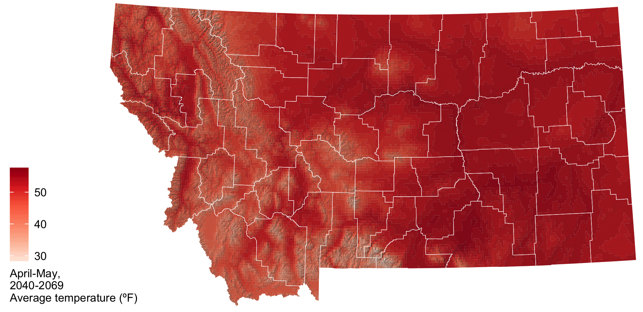

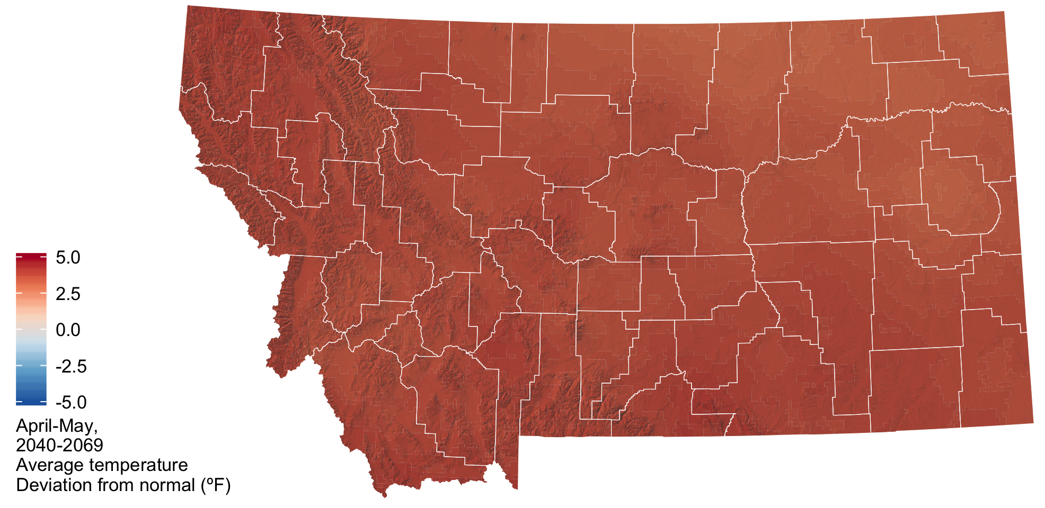

### Precipitation

By mid-century (2040–2069) average total precipitation in April and May is expected to be similar or slightly higher than our current precipitation. Because of increasing temperatures, a larger portion of total precipitation will be in the form of rain as opposed to snow.

